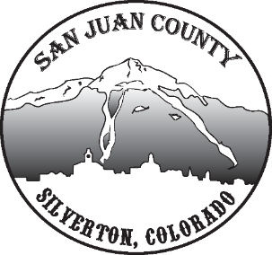

Economic Recovery Team
Meeting Date: 7/21/2020 10-11AM

Updates: Jim updates KUSA Channel 9 wanted to know how small towns were faring with COVID/Recovery/Tourism and the reporter will be in town interviewing tomorrow. They want to steer the story into a feelgood story, how we are recovering and coming together and surviving. Bill will talk about the student VISA problems and lack of employees.
Short Term: Wanting to encourage people to move here doing work remotely. Some businesses are already in town and talking with their company may be helpful in learning how to market for more. Laura added that they can do a statistical analysis to identify demography for more guidance. Willy expands that this is the right time to push for this, with people leaving the big cities and looking for smaller communities. Shane brings up revisiting infrastructure needs to make the transition smoother.

SWOT Analysis: Went over all areas of SWOT, see that document.
Shane thinks we should send this kind of survey out community wide, because it is usually the same people attending the meetings and it’s good to get more feedback. Lisa said that the large community who responded to the opportunity prospectus also came up with the same responses as we did with in the SWOT, supporting the data. It’s noted that many of our weaknesses are counterbalanced with opportunities. Kim said the SJDA board was looking at funding to bring someone in to tackle some of our opportunities.

Other: John said he has a line on masks 25cents a piece for another 20,000. They think it should get us through the summer.

