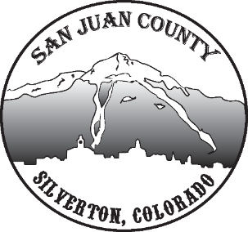

Economic Recovery Team
Meeting Date: 1/5/2021 10-11AM

Short Term Economic Recovery:
COVID Restrictions: Deanne – Businesses are struggling with 25% capacity. Willy asked if there is more assistance for them, example: 5 Star program (only available if you move into red level). Becky will look into this concern with Deanne. They wanted to see the positive rate after the holidays but now they can discuss it.
Food/Rent/Utility Assistance: Kim – Food assistance is coming in strong, especially from La Plata county. She’s wondering if we should open up food support to anybody at this time. Also, with rent support. Decided to add a couple disclaimers and get the rest of the assistance out into the community by May.
Surveys: Kim – Wants to get another survey out to the community. Need to see how people are doing with COVID and childcare etcetera. It will be a good comparison from the earlier survey to see where we are at. Lisa will go back over the questions with Kim before sending it out again.
COVID Tests: Zero positive tests after the holiday break.
Community Development Action Plan:
Heather – They are going into communities to come up with new action and goals. Sept 2021 Region 9 turns in our CDAP (updated every 2 years). They are our priority projects with a benefit across the community. We need to look into our next 2 years projects and remove those that no longer apply. Lisa suggests we circulate this with townhall and staff to get an idea for ideas out there. Willy suggests we go over the old goals. Will share last plan through google sheets for all to go over and make comments/suggestions. Went over a couple line items as a group.

