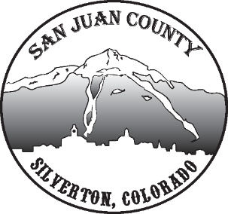

Economic Recovery Team
Meeting Date: 1/19/2021 10-11AM

Short Term Economic Recovery:
Deanne mentions a big issue right now is lack of snow.
Scott, we’ve had a really good Christmas, New Years, and Martin Luther King Day weekends. Many tourists and good for community.
COVID Tests: Deanne: 70% community creates herd immunity. No consistency or reliability in the current vaccine so unknown how long before we reach that percentage. Tests aren’t coming in as fast as they were told. If the plan works the way its supposed to, we wouldn’t get into herd immunity until summer. If the limitations on tests continues, it won’t happen as quickly as we hope. Heather O: stresses everybody needs to continue their vigilance to keep healthy and protected. This is a long haul.
Surveys: Lisa, Deanne and Kim are working on a survey for late Jan to early Feb. It will include childcare and other issues.
Long Term Economic Recovery:
Deanne spoke about Iron Horse and Hardrock 100, who are struggling, and they make a good impact on our community. Wants to see if the community even wants the Iron Horse here in May or not.
Kim mentions as grants come across our email, we should attempt to grab up to cover event fees and assist these events.
Heather mentions a specific grant available for special events if they meet qualifications. She shared that information.
Lisa dealing with capacity on their facilities and what they will be able to accommodate this coming spring/summer. Weddings and events may feel the affect.
Tourism Education: Michelle & Deanne have been talking about educating tourists coming in this 2021 season. Looking for a grant out of GOCO for the resiliency plan. Wanting to educate people as they come into town and support the alpine ranger program and responsible backcountry use.
SBDC Update: Kiki shared info about more PPP loans available. If businesses need help, send them to the SBDC. Businesses can reopen their originals too. EIDL: Businesses can access if in a low-income area and 20% reduction in sales to get that full 10,000 assistance. It isn’t easy for businesses to find out if they qualify, but the SBDC can help them.
Community Development Action Plan:
Heather O: Discussion over about 12 topics that need current progress updated. See spreadsheet provided for this meeting. Need to have this process complete by the end of this month. Next step will be to analyze trends of DATA they have already collected and go over resiliency framework from the state. That way our goals can be in line with the state. Finally, to go over the state economic blueprint from the state which affects programs that will be funded at the state level for economic development. She’d like to do that presentation by early February.

