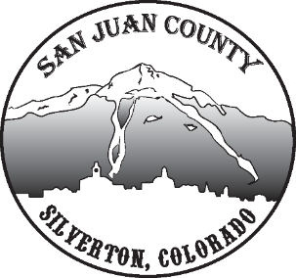

Economic Recovery Team
Meeting Date: 12/08/2020 10-11AM

Short Term Economic Recovery:
Public Health Update:
Becky - No active outbreaks presently. About 25 positive cases since the beginning. New Health order, spiritual gatherings have different allowances now. We are still in Orange level in SJC. Looking forward to the binax tests, easy self-administrating tests since they are very reliable. There are some business relief packages that require us to be in status: red. If we were to have any outbreaks we would potentially qualify.
More funding by grant to pay for staffing, cleaning, supplies starting in January. There will be a grant for vaccines. Today they administered the first vaccines in Europe. It will be a several month process as the vaccine is given in two doses. We are on the list to get vaccines, but no update on when that will be.
Ongoing fire danger: Deanne was in a call that confirmed the whole state is gearing up for many years to come of high fires. This is due to drought conditions.
Ice Lakes: Looking at putting up a potential reservation system at Ice Lakes with rsvp spot and pay a fee. Will likely cause a spill over to other hiking areas in the county. Molas is also going to change to charging for day parking. They’re working it out to omit locals from the cost.
Community Visioning: Willy mentions how the community visioning is becoming a really positive thing to set the stage for the next several years. Recognizing how difficult it is to get feedback from different mediums for people to participate. Talking about trying to get more involvement from other people than the ones that are always in the meetings. Willy asks for this group to put for their ideas of what the top three issues in each subcategory on the sheet he provided are, by the next meeting, so we can start prioritizing going forward.
Other:
Scott mentions a government grant available for rural broadband. Willy confirms that Mariam from the COG is working on this currently. One of the grant funding Willy provided in the reference material for this meeting would also work toward our broadband needs.
Update for MJ: Added the Hardrock Hundred to the SJC page and a Spanish translation form. Still working with Deanne for more information to put on their SJCODA page.
Laura M: Some SJC businesses did qualify for COVID impact grants up to 15k and she’ll be sharing that information with us shortly. (State and Federal funding, Energize Colorado, or Colorado GAP fund)
Kim: School is good. 104 people tested after Thanksgiving. They plan to do the same after Christmas Break too. Only school in SW open to in person.
Next meeting hold off until January 5th.

