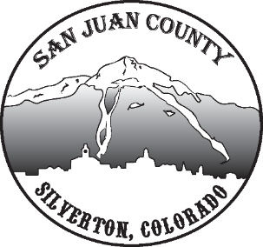

Economic Recovery Team
Meeting Date: 2/16/2021 10-11AM

Short Term Economic Recovery:
COVID -Becky & Deanne – No COVID since the end of January. Testing significantly lower amount each week now. Average about 20 tests a week. Staying on the 2.0 Dial in Yellow because increase of cases at Ski Areas. We are a vaccination site. Residency should not matter if we’re in the eligible criteria. Because of this, we’re seeing large numbers, but they aren’t local numbers. Focusing on second wave, but most of our local community is done with the second dose. State put a lot of counties in blue on the dial, we are not. They added a darker shade of Orange that starts restricting lodging. Something we need to consider because it would greatly affect us and our economic recovery.
GUIDELINES- Much discussion about what actual guidelines can be used to give upcoming weddings, events, and meetings under the current order.
BUSINESS UPDATE - Scott- Business community confirms people are still traveling and coming to town over the holidays. Kids doing remote learning while families travel. John R supports that with the reflection of sales taxes.
SCHOOL- Kim- Childcare gaps. They are translating their doc into Spanish and it will be ready to go very soon.
RENT/FOOD SUPPORT – Kim- She’s feeling uneasy about the support communication. Meeting a lot of needs, but no sense of reaching the full population. They will be meeting about this issue soon. Currently using paper and word of mouth, but it doesn’t seem quite enough.
Long Term Economic Recovery:
FIBER – Need to consider procuring a grant for getting Fiber to our streets and more of the community. They are putting a broadcast on the school and possibly the visitor center. There will be other blind spots around town, but they are moving forward, just slowly.
HOUSING- Scott- Town says the town needs to complete their Master Plan and zoning done before we can really tackle this.

