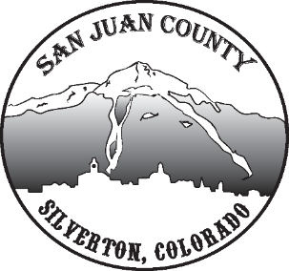

Economic Recovery Team
Meeting Date: 4/13/2021 10-11AM

Short Term Economic Recovery:
Sales Tax – Willy shared current sales tax year-over-year. Internet tax is up which is a good projection for the future, but there is concern about visitors and their impact. He wants to go back and compare restaurants and local businesses to the previous years to get a better handle on the effects locally. Especially, with fewer restaurants operating with limited space. Darlene said her hotel sales were up, but restaurant was a 50% decrease from the previous year.
Summer - Discussion about the upcoming summer. It was noted that last year had a large influx of tourists, but many were bringing their own supplies and escaping to the backcountry with less support for local businesses.
RV parks are already booked through July, and there is already a surge at the hotels for both June and July.
Fires – There have been warnings and projections for restrictions coming up quickly.
Staffing – Still concerned about getting J1s here. Between our country’s limitations and theirs, it makes them weary of coming to work. Also concern about vaccinations for staff.
Train – They might stage a locomotive in Silverton. Considering running short excursions from here due to COVID. The DNSNG is looking for every possibility to keep running even if La Plata moves up the COVID dial.
Looking into a possible TIPs class this summer.

